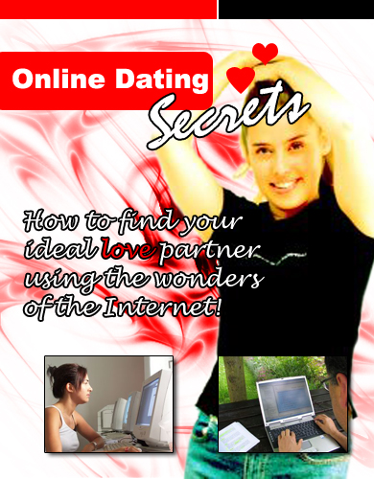

Online Dating Secrets

How to Find Your Ideal Love Partner Using the Wonders of the Internet!

LEGAL NOTICE

The Publisher has strived to be as accurate and complete as possible in the creation of this report, notwithstanding the fact that he does not warrant or represent at any time that the contents within are accurate due to the rapidly changing nature of the Internet.

While all attempts have been made to verify information provided in this publication, the Publisher assumes no responsibility for errors, omissions, or contrary interpretation of the subject matter herein. Any perceived slights of specific persons, peoples, or organizations are unintentional.

This book is a common sense guide to online dating. In practical advice books, like anything else in life, readers are cautioned to reply on their own judgment about their individual circumstances to act accordingly.

This book is not intended for use as a professional or counseling advice. All readers are advised to seek services of competent professionals in these fields.

This manual is written in Times New Roman for easy reading. You are encouraged to print this book.

Special thanks to: Samantha Villagran, for the wonderful photos!

Table of Contents

Preface – Why Look for Love Online? 6

Part I: Online Dating

Online Dating Explained 8

Online Dating: The Facts 13

Is Online Dating Effective? 16

Part II: Online Dating Secrets

The First Steps 20

Secret #1: Understanding the Unwritten Rules 22

Secret #2: Choose the Right Online Dating Service 24

Secret #3: Ask the Right Questions 28

Secret #4: Use Friends to Help You 30

Secret #5: Your Profile is Your Asset 32

Secret #6: Keep the Relationship on Slow Pace 35

Secret #7: Minimize Your Risk Factors 38

Part III: In Closing

Recommended Online Dating Sites 43

Is Online Dating the Way to Go? 46

Online Dating Secrets

By [Insert Your Name Here]

Preface – Why Look for Love Online?

Dear Friend & Customer,

Thank you for your investment in this guide to Online Dating Secrets.

You are probably pretty/handsome and sought after right where you are so why should you even consider going online to find love. How much time and money have you wasted on a relationship only to find out after six months that the other person has no intention of making a long term commitment?

Been there… done that, huh?

Wouldn’t you like to know what a person’s expectations and goals are before you spend all that time and money on the relationship?

Or maybe the reverse is true. You’ve been dating the same person for awhile and you really thought they understood that you did not want a permanent relationship. There are angry words exchanged and hearts are broken.

Don’t you wish that that other person had understood your motives from the beginning? Using an online dating service lets you know the answers to those questions and more before you invest time or money into a relationship.

Think about it.

For the price of one dinner out you can have a month’s membership in an online dating service. While dressed in your sweats or, for that matter, in your underwear, in one evening you can meet hundreds of people of the opposite sex who share the same goals for a relationship that you do.

No getting dressed for an evening out. No paying for dinner and a movie. All the guess work has been removed. Sounds like a bargain to me!

You still aren’t convinced? Here are 3 more good reasons to consider joining an online dating service.

- You don’t have to wait until the weekend to meet someone.

- If you work odd hours, there is always someone on line to talk to.

- If you are tired of seeing the same old people when you go out, internet dating sites are full of new and interest friends you haven’t met yet.

And that’s what this manual is all about, and I hope you will discover the secrets of Online Dating with me as we make our adventure through the coming pages together.

Ultimately, I trust you’ll land yourself on your first successful date after you absorb and apply the information within!

To Your Online Dating Success!

[Insert Your Name Here]

Part I:
Online Dating



Discover the TRUE meaning of Online Dating and why it’s the hottest phenomenon in 21st century relationship since sliced bread, the coming down of the Berlin Wall, and the end of the old fashioned match making days!

Online Dating Explained

The days of matchmaking and chaperoned dates are over. Our choices for friends and soul mates are no longer limited to people in our brick and mortar worlds, either.

And the distance is not really a question after all, because the best thing since sliced bread and Berlin Walls more than patched that up!

The door to the whole wide world is open to all of us. Walk through it. Open your mind. Explore the possibilities. Accept the challenges.

Our grandparents and great grandparents thought being able to talk to a person across the street without being face to face was an amazing thing made possible by the telephone. They accepted, even welcomed and embraced the strange new invention.

Now it’s our turn.

Our turn to accept and embrace new technology and learn to use it in every way it can make our lives better. The new technology is the Internet. It does so much to enrich our lives already.

We use “it” to shop, pay our bills, communicate with friends and family, research all things medical and financial, and even play games.

Introducing Online Dating!

Internet Dating is an idea whose time has come and it is about time we recognized it for the social tool it has become.

Online Dating services are many and varied. The cost range is great depending upon the features offered. However, the opportunities for friendships and even love abound. They are out there. You will need to put forth some effort to find them but the effort is worth it.

If you are a single person and have not yet joined the revolutionary Online Dating phenomenon, put it on the very top of your “to do” list. Find one or two that suit your needs, write a great profile, upload a nice picture and start having some fun.

You never know… the love of your life could be only a few clicks of the mouse away. Do it now don’t wait another minute!

The Growing Popularity of Online Dating

The number of people participating in Online Dating, or Internet Dating, has exploded over the last few years.

Why?

There are many reasons and over 40 million people can’t possibly be wrong. You can probably think of others but here are a few.

One reason is volume. There is almost a limitless supply of people online who all want the same thing… to find a date… and some who hope to find Mr. or Miss “Right”, their soul mate, the one and only love of their life.

The supply is constantly enlarging and changing as more and more people begin to use Online Dating services.

Another reason is that you can cast a wide net. You can email, chat with, and talk on the telephone to multiple possibilities. Keep the ones you like and throw the others back. If you don’t find anyone on the first try, keep looking.

Avoiding the awkwardness of a first meeting is another good reason to use Online Dating.

That first meeting is always the most difficult to get past and you can get to know a person really well before you have to meet face-to-face for the first time so it isn’t like meeting a stranger.

Online Dating is cost effective. All you need is an Internet connection and a membership to a reputable Online Dating service and most of them have a free trial.

For only a few dollars you can meet dozens, maybe hundreds, of people you might be interested in and all without paying for a single dinner date, movie ticket, or even a cup of coffee.

If you have not yet tried Online Dating or, as some call it, Internet Dating, you should consider giving it a try. Who knows? Mr. or Mss/Ms. Right could be only one click away.

But Does Online Dating Actually Work?

Yes, it does work! But like with everything else, there is a catch.

Millions of singles are joining, or have already joined, Online Dating sites and they can’t all be wrong. So, you ask, what’s the catch?

Finding that one-and-only for you takes time and effort. That’s the catch. You don’t just throw one line in the water and expect a miracle. It isn’t that easy.

There are different Online Dating sites for every possibility. Religious preferences, single men, single women, gays, people who only want “fun” (and you know what I mean by ‘fun’), people seeking marriage, and on and on.

Name anything and I’ll bet there is an Online Dating service to match. So, first you must find an Online Dating site (or sites) that meet your own needs, goals and desires and that will take time.

Obviously, you wouldn’t want to join a site that caters to Jews if you are Catholic and that matters to you.

You have to write a great profile and post a picture. The important thing here is to be honest. Being funny and original will make your profile stand out among thousands.

The picture needs to be as flattering as possible but it needs to reflect the real you, too. All of these things take more time.

You must make the first move by contacting prospects by email and you can’t use a “form” email.

Each contact needs to be different and special. You need to make reference to their profiles and not just drool over their picture. You will need to answer emails that you receive and do so promptly… but not TOO promptly.

This takes time, too.

In other words, you are going to have to work at Online Dating. Online Dating requires a commitment of your time, effort and energy.

Online Dating: The Facts

In a recent study, it was found that 2 out of every 5 single people between the ages of 24 and 50 use, or have used, Online Dating services.

Imagine That!

Think about walking into a room where there are 100 strangers and finding out that 20 of them use the same mechanic that you do. The odds are mind boggling.

They would easily confess to using the same mechanic but they won’t confess to using an Online Dating service.

Why? There still seems to be some stigma attached to Online Dating no matter how effective and rewarding it has become. Yet, it thrives and it would be a pretty safe bet that if all 100 strangers are single and between the ages of 24 and 50 that 20 of them do use, or have used, Online Dating services.

Another fact is that only about 5% of people who use Online Dating services actually establish a relationship with someone they first make contact with.

OK, think about another room full of 100 strangers only this time they all are of the opposite sex and eligible. If you walked into that room in the real world, how many would you be attracted to? Maybe 10 if you are really lucky, right? Internet Dating is no different so don’t expect miracles.

Only 10% of people who join Online Dating sites actually get any replies and that is a truly sad fact.

The reason is that 90% don’t bother to write an interesting profile or upload pictures of themselves.

That’s a lot like fishing without baiting the hook. I wonder what they expected. The 10% who do get noticed have posted upbeat profiles and pictures.

Last but not least is that paid sites are better than free sites. The reason is that they work.

On free sites there is absolutely NO screening process at all! The fee for joining a paid site is small as compared to going out for dinner or buying movie tickets and you meet a lot more people in a lot less time if you work at it.

What Online Dating Isn’t

Now, it’s time for me to clear some assumptions and dispel the common myths about Online Dating. Some people, especially those who have lived a little longer, still think there is some stigma attached to Online Dating.

They think a person must be an odd-ball, pervert, or totally unacceptable in the real world to have to resort to using an Online Dating service. They couldn’t be more wrong.

Online Dating has exploded in the last few years. Over 40 million people of all ages, both sexes and from all over the world can’t be wrong. These same people, also, think internet dating is dangerous.

It could be but it doesn’t have to be if a person uses a little common sense. The same kind of common sense that would keep you from giving any stranger you met on the street your personal information.

We all use the internet to research almost every aspect of our lives… medical, major purchases, jobs, investments, etc. We gather information that helps us to succeed in all ways.

We make travel plans, we get information about colleges, we shop, and we download music. The internet is not just for geeks anymore. Why not use that same internet to insure our success in our personal lives? Meeting people expands our horizons and enriches our lives.

The whole world has shrunk to a single neighborhood because of the internet. Dating the girl or boy from next door could mean someone from half way around the world now.

You could find the love of your life in the town you live in or in a city 50 miles away or 1000 miles away or even in another country. The internet makes it all possible.

There is no stigma attached to using Online Dating services and it’s safe and effective. It makes good sense and is an efficient use of our time, energy and money.

It’s dating in the 21st century!

Is Online Dating Effective?

Online Dating is not a last resort for social misfits. It is an excellent tool for those who lead busy lives, deal with a lot of shyness issues, or just want to expand their horizons.

First you should decide what you main objective is for dating online. Is it just for friendship or only to have someone to talk to?

Are you looking for a short term relationship to get you through a rough spot or are you searching for a long-tem, lasting bond? Are you only looking for casual dating with many guy/girls?

After determining your objects, the next thing you should do is write a personal ad that makes your profile stand out among many. It should be creative with a different spark and should never sound desperate. Use romantic imagery and humor.

The next thing is uploading your picture. This picture is the most important one so choose wisely. Don’t choose the one that you think makes you look the prettiest/most handsome but the one where you look the happiest. A great smile melts hearts and minds.

In later pictures you post, choose ones that show you enjoying the things you love to do like sailing, camping, reading, dancing, playing an instrument.

OK. Now you are ready to start Online Dating but wait. There’s more you need to know. When you send an email to answer an ad, always include something personal that indicates that you have read the person’s profile and don’t just drool all over the picture.

Always be funny, creative, different, and try to appear approachable. If you are answering multiple ads, for goodness sake, do not use copy/paste. Make each letter original.

When you get a reply the relationship has begun. Proceed wisely and with caution.

Online Dating can work for you. As a matter of fact…

Online Dating is Popular!

The explosion of Internet Dating is amazing. It has gained popularity at unprecedented speed. The reason for its popularity is that it works and it fits into our busy lives. We all work at least 40 hours each week; some of us work many more hours than 40, just to make a living.

Add commute time, preparation time and there just isn’t a lot of time left for social time except for weekends…at least we hope we have weekends off.

Hence, we turn to the Internet like we do for so many things. We use the Internet to shop for “stuff”.

We no longer have the time to visit brick and mortar stores so we go online to find the things we need. We pay our bills online because we just simply do not have the time to write out paper checks, put them in paper envelopes, lick stamps and go to the post office.

That’s just the facts of life of the 21st century.

We use the Internet for everything else… why not for our social needs? It doesn’t make much sense to think that the love of our lives is going to walk through the door of a bar we just happen to be at on any given night. That’s what I call a long shot.

Doesn’t it make a lot more sense and much better use of our time and resources to be able to go through hundreds of profiles and pictures in a single evening than to leave one of the most major of life’s decisions to chance?

It does… it really does.

If you haven’t yet joined an Online Dating site, you should certainly consider doing so and as soon as possible. (ASAP) give your social life a good kick-start and start enjoying dating again.

Part II:
Online Dating Secrets



Uncover the SEVEN (7) key Secrets to Online Dating Success. They’re powerful yet simple ones that people’s emotions often bury them under their noses!

The First Steps

Before I reveal the 7 Online Dating Success secrets to you, you might worry since you probably have never done any Online Dating before and you really don’t have a clue where to start, right?

Online Dating is the modern way to meet people and expand your horizons. It’s the equivalent of the ‘Social’ in years gone by… and those years have gone by and reside only in the memories of those who have lived more than a few years on this earth.

The Worse Alternatives

Are you tired of friends and relatives (your mother) “fixing you up” with dates with people that you have absolutely nothing in common with? Or how about “blind dates”? Is there anything worse than that?

Well… maybe.

How about meeting the losers in bars? That’s even worse! So now, you are ready to take matters into your own hands and move up to Online Dating.

But how do YOU start?

Online Dating: The Basics

The first thing to do is to find and Online Dating service and there are so many to choose from.

You need to find one that meets your needs. There are the general ones where you just post a profile and picture and hope for the best.

There are the specialized ones that are for single women, single men, Jewish men and women, gays, even outdoor enthusiasts. There is one for almost any specificity you can think of. So choose wisely.

The next thing you need to do is write a profile. (More on this will be discussed in the later parts of this guide.)

You answer all the obvious, general questions such as:

- Sex,

- Age,

- The general vicinity where you live,

But you need to go a lot further. Your profile needs to fresh and funny. Make it stand out in the crowd. You need to post a picture of yourself. Again, most of these will be covered in the later parts of this guide.

Warning! Don’t post any photos of yourself that is about 10 years old!

Post the most flattering one you have that shows you as you really are. Then you need to work hard at contacting others that seem interesting and replying to those who contact you.

Having said that…

Good luck in discovering the 7 key successes to Online Dating!

Secret #1:
Understanding the Unwritten Rules

Over 40 million singles are now using, or have used, an Online Dating service according to a recent survey.

That’s a mighty huge business we’re talking about here, and that has started a whole new era of dating with its own rules.

We all know the rules about how to stay safe on the Internet. We’ve been told a thousand times NOT to give out our personal information and not to trust everybody.

We already know those things. But do you know the unwritten rules? There really are some.

And it is THESE rules you need to know, written or not! Here’s your first key towards Online Dating success.

Avoid Disappointment

Keep your expectations low. As nutty as this can sound, it’s better to be pleasantly surprised rather than bitterly disappointed.

96% of people who participate in Online Dating don’t find a compatible match, and this statistic will stand true even in time to come. There’s a reason for that.

That 96% usually give up after one or two dates that don’t turn out to be the love of their life. You must be persistent. “If at first, you don’t succeed, try try again.”

And keep on trying until you find the right one. He or she is out there somewhere but it takes searching, screening and lots of dates to find him or her.

Don’t Hurry to Respond an Email

This is yet another nutty thing as it sounds. I know... I know… most experts will tell you to respond right away but you really don’t want to do that. Take your time.

Compose a response that is thoughtful and appropriate. Don’t answer on holidays or weekends, either. Why? It makes you appear too eager or too desperate.

“When in Doubt, Tell the Truth”

Or so quoted by Mark. This serves as more than good advice in Online Dating.

When you write your profile, there really isn’t any point in shaving years off your age, underestimating your weight or over estimating your height. So, don’t even try it. Be yourself.

Once you meet in person all of those lies will be revealed and you will lose the “trust factor” and probably put an end to any hope of making the relationship a long term one with a “happily ever after” scene.

Secret #2:
Choosing an Online Dating Service

Choosing the right service or services for your self can be very tricky. You need to be sure you know exactly what you want.

The high profile services provide a lot of bells and whistles like instant video messaging and then there are specialized services for Christians (or gays) or specific ethnic groups.

The service you choose will depend upon what is important to you. There are hundreds of Online Dating sites. It can leave your head spinning just thinking about it.

The bottom line of choosing a service is what is important to YOU. The larger and higher profile sites have more features but are mainly geared to dating personals in general.

They have international memberships so if you are looking for someone in your immediate area, you could have a problem.

On the other hand, if you live on top of a hill a half block from the middle of nowhere like I do, you might find that some driving or even flying can’t be ruled out in your quest for friends or lovers.

The whole point of the Internet is to erase borders and expand our horizons, isn’t it?

The truth is that if the opposite sex in your area/state/ country won’t give you the time of day, in another area/state/country you might be described as a babe or a hunk. It all depends on the point of view and we don’t all see things or people the same way.

Perhaps you are looking for friends or more than friends that fit into a specific niche.

This is big business. You can find dating services that cater to every fetish you can think of, all ethnicities and even religion. There’s no reason you can’t find an Online Dating service that can help you to find the one person on earth that is the one for you.

They are looking for you, too. Right here on the Internet!

The Right Online Dating Service for You

The options for Online Dating sites can be confusing, to say the very least. There are so many to choose from and there is more every day. So choosing wisely is the all-important first step to a successful Online Dating experience.

Cost

The price varies widely between sites determined mostly by the extras they offer. So first determine how much money you want to commit. Do you want a free trial before you buy? How long should that free trial be? Do you want a money back guarantee? Only you can decide these things.

Profile Criteria

How much information do you want to provide and how much information do you think you need to determine whether another person is someone you would like to know? Some sites want detailed profiles. Others do not. It’s your call.

Matching Systems

This is offered on some sites now. They use physiological profiles to match people with others that seem compatible. Would that be a useful tool for you?

Safety Features

While this feature varies for different sites, Some sites do background checks and determine such things as marital status and criminal history. Is that something that you feel is important?

Chat Rooms/Instant Messaging

This feature is common on several sites related to the dating niche. Would you pay extra for this or would you rather stick to email?

Outside Events

Outside events such as speed dating is offered on some sites. Would you be at all interested in attending such events?

Search Capacity

Search Capacity varies widely between Online Dating sites. Some are limited to age; sex and geographical location while others have a virtual laundry list of requirements you can search for.

So you see, what a site offers is of the utmost importance for you to decide which one is right for you. Do your homework, choose which site’s the best for you, and then get busy – looking for your love partner, of course!

Secret #3:
Ask the Right Questions

You can find the man or woman of your dreams with Online Dating. Since it started, Online Dating has brought people together who would never have met any other way. You can make your Online Dating experiences better by starting them right.

When you begin an online friendship that you are hoping in your heart will turn into a romantic relationship, there are some questions you should ask right away. The answers you get can tell you whether to proceed with the relationship or head for the nearest exit.

The Most Important Questions Answered

First you need to ask in as diplomatic way as possible, “What is the biggest mistake that people make when dating online for the first time?”

The answer you get can reveal a lot about the person. Like their attitudes on the opposite sex and what kind of issues are vitally important to them in their other relationships.

The next question that you need an answer to is, “What qualities in a guy/girl do you think are important for a successful relationship?”

If the person tries to pass this off as a joke or doesn’t have an answer, it probably means they really haven’t thought about it and are not looking for a serious relationship. In this case, you will do well run the other direction!

And last but certainly not least, you should find out what happened to end the person's last relationship. If they tell you it was all the other person’s fault or take all of the responsibility for the breakup themselves, that is not a good sign. The answer you really want is that they just grew part or mutually consented to the break-up.

Remember that Online Dating is more of a process than instant results, even though the Internet is often associated with convenience and speed. Also remember that the object of emails, chats and phone calls are to get to know the other person.

You want to know what kind of person he or she is before you actually meet them in person. So ask questions and answer questions the best you can.

Important! In as simple as this secret may sound, MOST singles DON’T really think much about these important questions that they themselves and their partners do not often answer or even reflect on. It’s like spelling otherwise than Online Dating success!

Secret #4:
Use Friends to Help You

Now, this is something most singles often refrain from when it comes to securing a greater relationship that requires greater understanding and acceptance. For odd reasons, I don’t know why. But don’t go without putting this secret into practice!

Out Here in the Real World…

… We always ask our friends for introductions to eligible people and for their opinions about people we are dating, don’t we? Of course, we do.

The Internet is just an extension of the real world so your friends can help you there and you can help them. If you have joined, or are considering joining, an Online Dating service, ask a friend or two (or even three) to join you.

You will double or triple your chances of meeting the right pair for you. That’s very possible, because the next time you talk to your friends, instead of asking them if they would like to join you at a movie, ask if they would like to join you on an Online Dating site.

Chances are, they’ve been thinking about doing just that and it will help both of you to find true love or, at the very least, some interesting new friends.

How Can this Help?

Firstly, it doubles your chances of meeting someone. Your friend can recommend someone to you and you can do the same for him or her. Two sets of eyes are better than one.

Another way it can help is that you can arrange a chat room date with your friend as well as prospective dates. Chatting is always easier in a group where you really know at least one person.

If you both meet someone, you can arrange to double date on your first off-line meeting. The old saying, “There’s safety in numbers.” is true.

Important! Most singles seek a second opinion before dating someone so if you are both members of the same site, you can get that second opinion easily.

Call your friends today and get going on finding that special someone. You can do it!

Secret #5:
Your Profile is Your Asset

Once you have chosen an Online Dating service, you will be required to write a profile. Writing your profile is usually one of the first things you do. It’s also one of the most crucial factors to your Online Dating success – you either land on a date, or stay single.

Important! The most important thing to remember is that “Honesty is the best policy” because it IS the best policy.

The object is to find someone who will really like (and maybe eventually love) the real you. It’s hard to write the truth about yourself and not what you hope others think of you but you must try. You need to be honest with yourself and honest about yourself. It’s the first step in meeting that special someone.

THE “someone” who will love you, quirks, imperfections and all but you don’t need to sell yourself short either.

Analyzing your Past Relationships

Really think about the things that were right and the things that were wrong. For instance, if you really hated that the last person you had a relationship with smoked in the house or used bad language, say so.

Just because you are lonely or your subscription is about to run out is absolutely no reason to compromise. If you hated those things before, you will continue to hate them.

Be sure to include in your profile the life style that is important to YOU. If you are a couch potato, you will not be compatible with an outdoor enthusiast or vice versa.

If you love music and theater, you will not be happy with someone who is tone deaf or hates plays and movies. Remember, don’t compromise!

If a physical attribute is important to you, say so and be honest about your own physical appearance.

For instance: If you are a guy who is 5’8” and you are not comfortable being seen with a girl who is 6’ something or a girl who is 6’ something and not comfortable being seen with a guy who is 5’ 8”, you need to say that.

Avoid These Profile Disasters!

I have seen enough profiles to be able to tell you at least three things that are certain to cause you to fail miserably this endeavor.

Out of the thousands of profiles I have read, there were, maybe, 5 that caught my attention, 100 that were acceptable and the rest were awful. Think about this: your profile and picture are the two things that will cause another person to contact you and, of the two, the profile is the most important.

So you need to spend some time and give some thought to writing it.

The First and Biggest Mistake…

… I’ve seen made are statements like, “I’m the guy/girl your daddy would want to shoot on sight.”

Uh-uh. Big mistake…VERY big mistake.

It or statements like this that are over used and over rated. Your profile needs to stand out not sound like a million others. Go read the profiles of others and avoid words and phrases that are used too often.

And another Dumb Profile Mistake

The next one that I really hate is, “I could be the one you are looking for.” Well, duh! Maybe you are, maybe you aren’t. Maybe he/she isn’t the one YOU are looking for. If you’ve written that down…back space.

Tell people what really makes you happy and makes your heart beat a little faster. Tell them the things that you are passionate about.

Tell the FACT that let them know you are an interesting, well-rounded fun person and one that they will want to know.

Spelling and Grammar Counts!

The misuses of words or spelling mistakes make you sound… well… dumb. There is no other word for it.

Tip: MS Office has a spell check and will check grammar. If you don’t have that, at least get someone who knows to read it over and correct your mistakes before you post it.

Secret #6:
Keep the Relationship on Slow Pace

Online Dating can be fun… even exciting. It can open new and interesting relationships for you. Who knows? You might even find the love of your life online. Why not? You can find everything else.

However, you do need to follow some simple guidelines to make your Online Dating experiences not only fun but safe, as well.

The world is full of nice people but there are a few bad apples so you will need to protect yourself. If you haven’t yet tried Online Dating, here are a few things to consider.

Start Slow

The first thing is to start slow. Use only reputable Online Dating services. Trust your instincts about prospective dates. Remember the old saying, “If it seems too good to be true, it probably is.”

Warning! Be very careful not to give out too much personal information to strangers. Never give your real name, address or phone number. Do not reveal where you work. Get a free email account like Hotmail or Yahoo! and do not give your “real” email address until you know a person well.

Use good common sense and due diligence about trusting people. We all want to trust and to be open. But it’s not a good idea to do that until you are well acquainted with a person you have never met before.

Tip: Don’t limit your contact to just online chats. Talk on the telephone after you are comfortable giving your phone number. Ask for a picture, too, preferably a recent photo.

Don’t be pressured into a face-to-face meeting until you are comfortable with it and then make the first meeting in a public place. Arrange with a friend to call you during your first meeting to be sure you are safe.

Online Dating can be not only fun but rewarding. It does have pitfalls so just use your common sense and stay safe.

Something Else You Should Know

Even as you start slow, you should keep the relationship on a pace you are comfortable with. Don’t rush!

It’s also important NOT to reveal EVERYTHING about yourself in too short a time span. While protecting yourself is partially the reason, the other good reason is that you don’t want to “spoil the suspense too soon” or “burst the bubble” like some would like to quote.

For example, if:

- You are an avid tennis player,

- You love to play the guitar,

- You like reading science fiction,

- You admire some celebrities, and so on,

It is best NOT to reveal all these to your chosen partner too soon. Dispense your personal information bit by bit, progressive by time, in as much interesting a person you can be.

This is often the weakness of interesting people – they tell everything about themselves so much so it’s difficult for their partner to digest.

While it is perfectly understandable one would love to share his or her interests with his new found partner across the line, the consequence is often bad when he or she runs of out interesting things to tell.

Call it a way to quickly kill the future conversations and reasons to meet the other person online, if you want to, but given the several reasons, it is ideal if you reveal your personal information and interest on a progressive manner, in the name of personal safety or not.

Secret #7:
Minimize Your Risk Factors

As you probably accept by now, Online Dating is an efficient and fun way to meet new and interesting people. However, Online Dating can be risky business and you need to protect yourself.

Most people you meet on line are exactly who they say they are but there are the perverts and sexual predators so you should use some good judgment while getting to know the stranger you have just met.

Risk Management #1:
Don’t Give Out Any Personal Information until You Have Gotten to Know the Person.

Never give your real name, address or phone number until you are sure the person you are talking to is who they say they are. Perverts, sexual predators and just plain garden variety weirdoes come in both sexes, all ages and in all shapes and sizes.

It’s truly better to be safe than sorry.

Risk Management #2:
Take Your Time Getting to Know the Other Person.

You will see a picture sooner or later of him or her. Don’t be fooled by outward appearances. The real person is the one you need to get to know.

Honest and faithful are qualities that will last but beautiful and handsome will fade with time. You don’t have to spend 24/7 with a person to find out who they are. You do need to listen to what he or she is saying carefully.

Once you think you know this person well enough to exchange personal information, don’t stop there. The Internet is a wonderful place where you can learn just about anything and everything about anybody and in just a few minutes.

Risk Management #3:
Do your Homework!

Check them out. There is an old saying among journalists. “Your mother says she loves you but check it out.” That is good advice for Online Dating and for “real world” dating too. Don’t take everything the other person tells you at face value.

Online Dating Mistakes You Should Avoid Doing!

Luck doesn’t necessarily have much to do with making a great relationship when you are dating online.

There are lots of things that you can do right and even more that you can do wrong. If you really want your online friendship to turn into a real and romantic relationship, you need to follow some guidelines.

Online Dating Mistake #1: Profile Discrepancy?

The first one is that if you are going to post a picture of yourself or send a picture to an online friend, make it a picture of you and not some really beautiful/handsome friend. Sooner or later you might meet this person and the truth will come out anyway. So be honest. Don’t describe yourself as thin and 5’3” or really ‘buff” and 6’1” unless that is true.

Online Dating Mistake #2: Not Being Punctual!

When you make a date to chat online or talk on the phone, be there and be there on time. You need to put forth the effort to keep the relationship going, too. If you don’t, the other person will soon lose interest and move on.

Online Dating Mistake #3: Detouring the Conversation into Timbaktu!

Make your conversations interesting and realistic. Don’t just joke around and make “cute” remarks. Find interests you have in common like music or movies. You’ll need to get around to talking about goals and values. Pay attention. You can learn a lot about a person’s views on love, respect and commitment.

Online Dating Mistake #4: Expecting Perfection from Your Partner

Don’t expect to find Mr. or Miss PERFECT. They do not exist. All humans are flawed. The point is to find ones with flaws you can accept. It’s the little quirks and idiosyncrasies that make each of us different and interesting.

Online Dating Mistake #5: Rushing Your Relationship on a Freight Train

Rushing into any relationship is always a mistake. Take your time.

Get to know the person well enough that you feel comfortable and at ease when talking to them and really hate to see a conversation end.

Then, and only then, will you be ready to meet them in person and take your relationship to another level. You need to be the best of friends before you can be in love.

Part III:
In Closing



Kick start your Online Dating journey now – with the 7 key Online Dating success principles at your finger tips!

Recommended Online Dating Sites

Match.com
http://www.match.com/

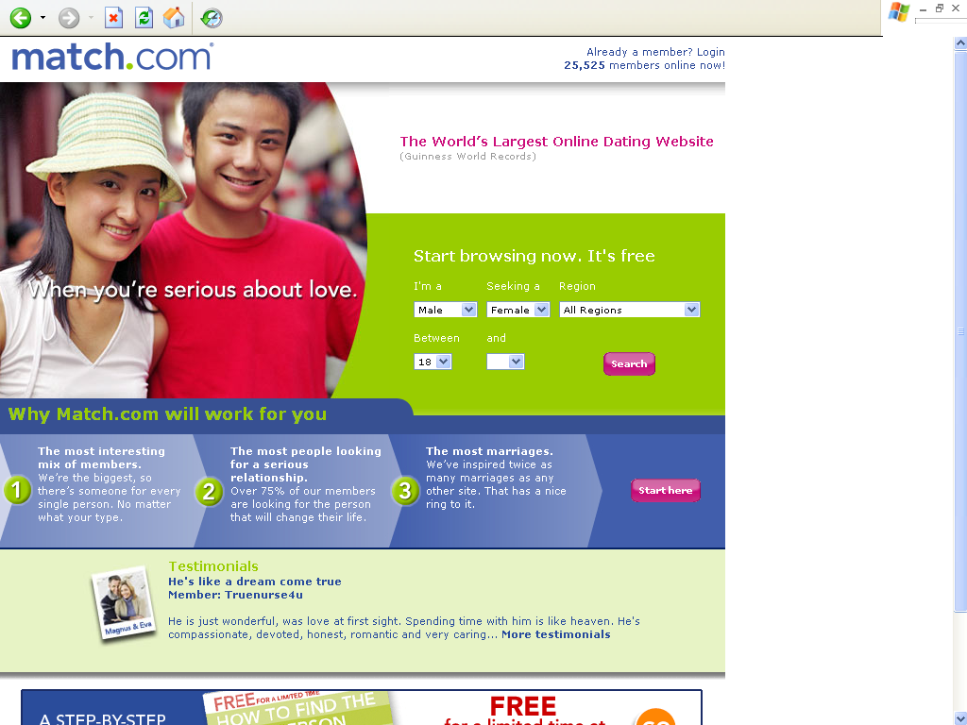

Search Your Love
http://www.syl.com/

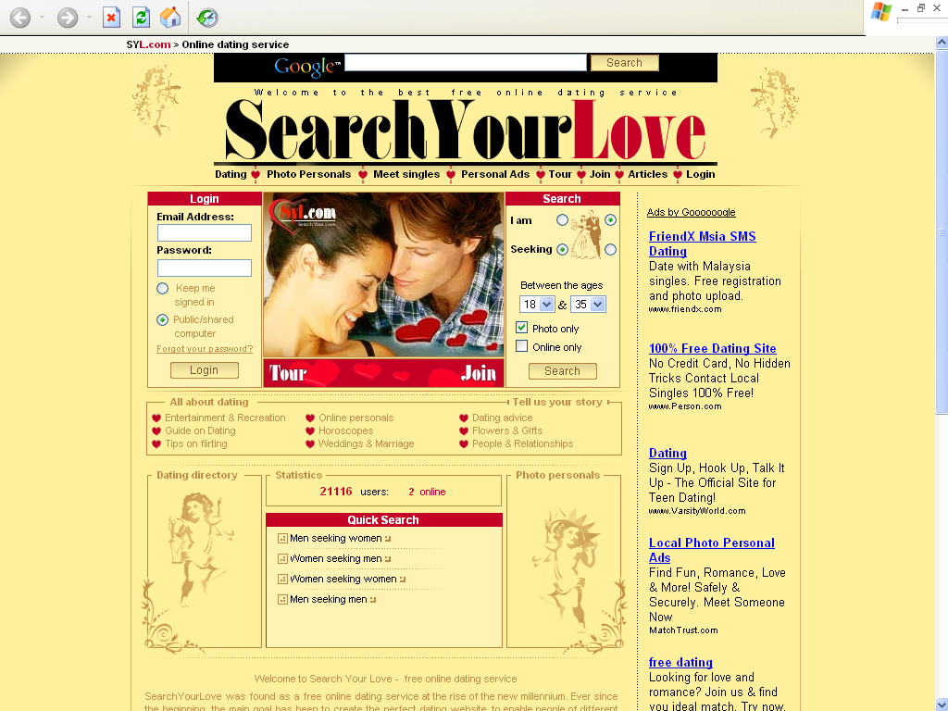

Friendly Zone (For Asians)
http://fz.aasiai.com/

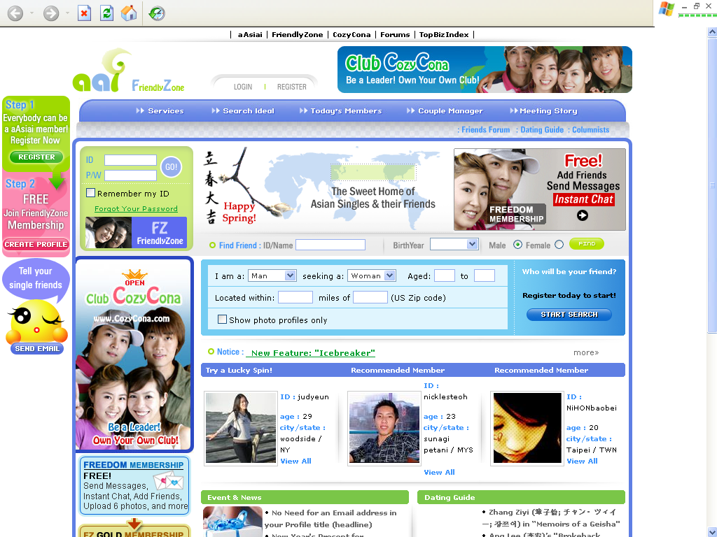

American Singles (For US Citizens)
http://www.americansingles.com/



Executive Internet Dating
http://www.executiveinternetdating.com/

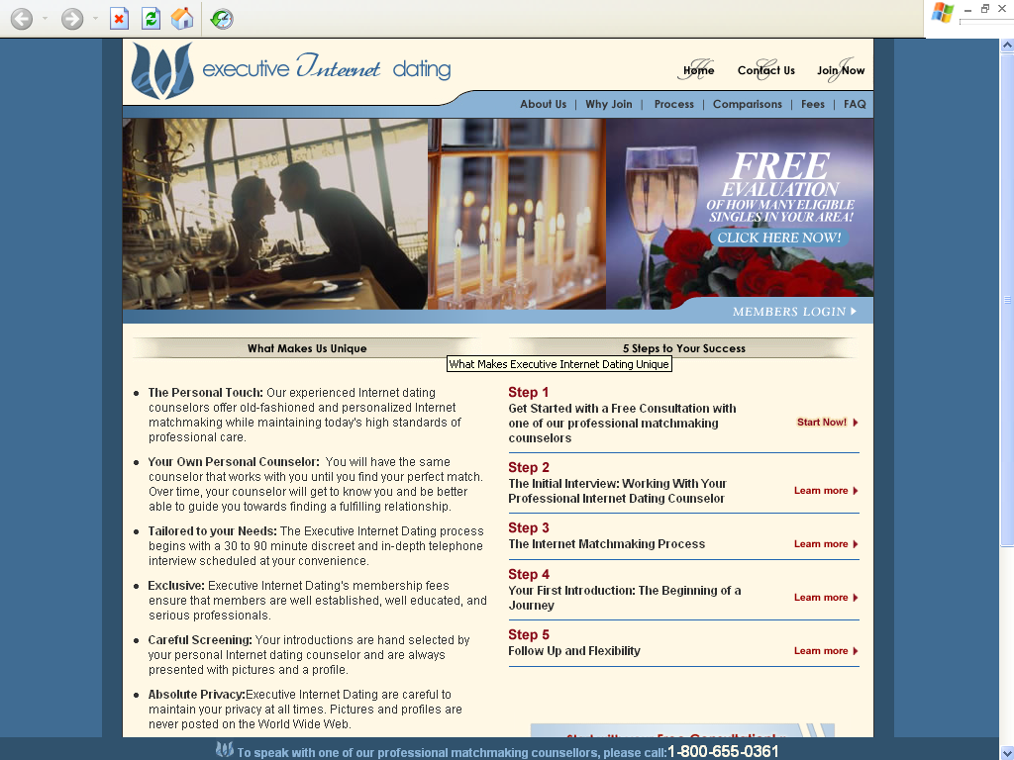

Dating Pearl
http://www.datingpearl.com/

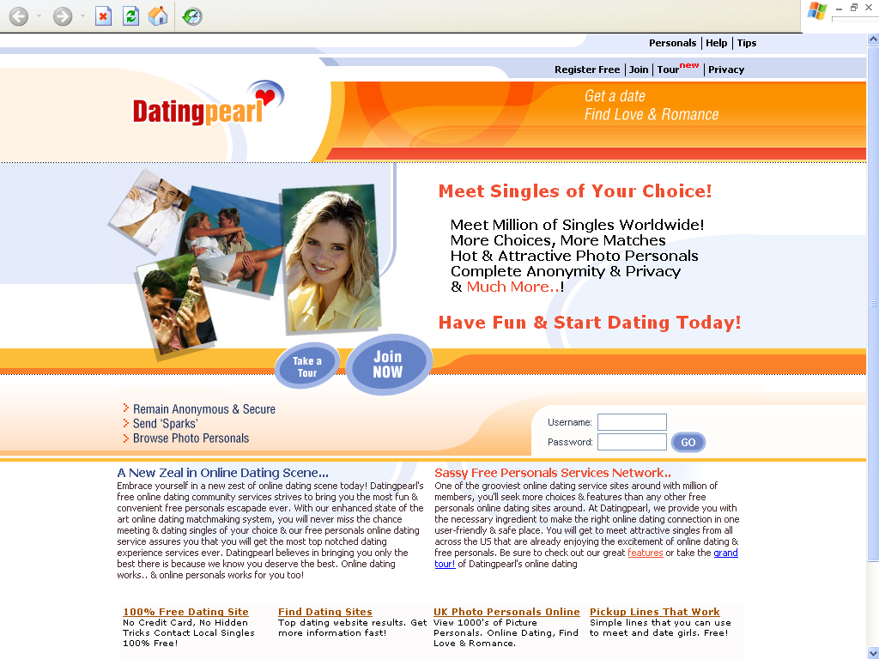

Is Online Dating the Way to Go?

Jumping into Online Dating can be a bit daunting, to say the least. Is it the right way for you to go? Probably.

What do you have to lose? There are many reasons for trying it and, at the very least; you will expand your social circle and meet some interesting people… maybe even find your dream girl/guy.

Online Dating Today

Online Dating services expand daily. There are over 40 million Americans who are using them… they can’t all be wrong.

Online Dating is just plain fun! You meet people from all over the world and it’s safe and easy. It doesn’t matter whether you are looking for someone close to home or from half way around the world, Online Dating offers all those possibilities.

Millions of singles are right there at your fingertips ready for a conversation with you. Hundreds of thousands of new people sign up every month.

The benefits are innumerable. Right now there are millions of active members online just waiting to talk to someone like you.

You can quickly separate those who are looking for casual relationships from those who are looking for long term relationships and choose the people who share your own goals and interests.

Unlike meeting a stranger in a bar, you have the answers to a lot of questions before you ever say, “Hello”.

The features on most Online Dating sites are wonderful. You will have access to thousands of profiles, photos and even audio and video clips. Some services even match you up with others according to your profiles.

Dating has never been more fun, not to mention, less expensive. Yes, you pay to join any dating service that is good.

The free ones don’t offer much. But the benefits of Online Dating are many and certainly worth the small fee that you pay for so much fun and opportunity.

Show Your Care in Online Dating Relationships

Regardless of fun, Online Dating can be intense and serious business since you are sharing time and investing part of yourself.

As this guide draws to a close end, I would like to offer you some golden tips on making your Online Dating rather memorable – in the offline world, too!

The truth is that you need to reach out and show you care in Online Dating relationships just as you do offline.

Here are just some of the many ways to do that:

- A favorite movie – Head to a movie review site like movietickets.com and share info about favorite movies your mate brings up. Discuss the reviews and trailers together.

- Coupons – Find special online coupons in your mates favorite online stores and local area (like pizza shops). Even Ebay and Paypal offer programs.

- Tips – Keep an eye out for special tips to share with your date; health tips, automotive safety, computer and Internet safety, industry tips for work, etc.

- Humor – Good clean fun is always nice to add to relationships. Share jokes, comics and funny photos - -all G-rated!

- Quotes – Search for sites that share quotes from famous people and share these for inspiration and education.

- Share an eZine subscription to a favorite online magazine, if it’s allowed in your subscription. Be sure to check out DoubleYourDating.com.

So don’t forget to show you care! Reach out online in special ways, too.

Until Then…

With a better understanding of Online Dating and 7 success secrets at your disposal, it’s now up to you to change your life into one rather memorable adventure – the 21st century way!

All the best, and to finding your new love partner across the phone line!

To Your Online Dating Success!

[Insert Your Name Here]

